UX Design Project
Recycling Information Website

Student Name:
Gerard McGreevy
Student ID:
D00284284

Section 1: Introduction and Overview

1.1 Project Overview
The chosen project is a multi-page educational website on recycling. The website was created using HTML, CSS, and JavaScript as part of a first-year web development course. It aims to inform users on recycling's significance, worldwide issues, historical evolution, and societal objectives.

1.2 Website Structure
The website consists of five distinct pages:
- Home (index.html) includes two embedded YouTube videos, an image gallery, and an introduction to recycling at home.
- The significance of recycling is explained, along with its economic and environmental implications.
- Countries Failing to Recycle: Provides comprehensive data on the world's top five underperforming nations.
- Development of Recycling: Discusses how recycling policies and practices have changed over time.
- The history of recycling in the UK is traced from 1031 AD to the present.

1.3 Key Functionality and User Interactions
- There is a horizontal navigation bar on every page that allows you to navigate between sections.
- Toggle between reading more and less: Collapsable content is managed using a JavaScript toggle button.
- Image gallery: Clickable images on the site go to different topics.
- There are two YouTube iframes containing embedded videos on the homepage.
- Social media links: Icons pointing to Facebook, Instagram, YouTube, and X.
- Footer: Offers contact details, including name, phone number, and email address.

1.4 Potential Issues Identified
- Text contrast and readability are decreased by using a background image on every page.
- The "Countries failing to Recycle" navigation link is incredibly lengthy and unclear.
- The Read More button is easy to miss and lacks visual emphasis.
- The navigation bar and gallery overflow on small displays, indicating that the website is not fully responsive.
- Every page has a publicly visible personal phone number in the footer.
- Users do not need to manually browse every page due to the lack of a search feature.
- There is an accessibility issue with all gallery photos having empty alt attributes (alt='').

Section 2: User Profiling and Personas

2.1 User Profile
Attribute | Description
Age Range | 16 to 65 years
Primary Motivation | Learning about recycling for personal, academic, or environmental reasons
Technical Ability | Basic to intermediate — comfortable using a web browser
Primary Device | Laptop or desktop; some mobile use
Usage Context | Home, school, or library environment
Prior Knowledge | Varies — beginner to environmentally experienced
Frequency of Use | Occasional to regular — for research or personal interest

2.2 Differential Choices
Age, degree of environmental consciousness, and computer literacy distinguish the three identities. These elements have a big impact on how each user interacts with the website and what they require from it.

2.3 Persona 1 — Serban Moldovan
Field | Details
Name | Serban Moldovan
Age | 20
Occupation | Second-year Computing in Software Development, DKIT
Digital Literacy
uses online resources daily for research
Environmental Awareness | High — passionate about sustainability and environmental policy.
High

Goals
- Research recycling statistics and historical data for college assignments.
- Find well-referenced, factual content she can cite in academic work.
- Quickly navigate between topics without reading every section.

Frustrations
- Dense text blocks without clear structure or headings.
- Lack of citations or sources for statistics.
- Sites that are not mobile-friendly between lectures.

UI Preferences
- Clean, structured layout with clear headings and short paragraphs.
- Search or filter function to find specific topics quickly.
- Mobile-responsive design.

Why Aoife is the Primary Persona
Serban represents the most likely and most frequent user of this website. She has the clearest task goals, the highest information requirements, and the most demanding expectations around content quality and navigability. Designing for Aoife naturally raises the baseline quality for all other personas.

2.4 Persona 2 — Luke McGloin
Field | Details
Name | Luke McGloin
Age | 21
Occupation | Second-year Computing in Software Development, DKIT
Digital Literacy | Moderate — comfortable with websites and email
Environmental Awareness | Moderate — interested in environmental issues

Goals
- Find simple explanations of recycling to share with his children.
- Understand practical benefits of recycling in everyday life.
- Watch short video content as an alternative to reading.

Frustrations
- Websites that are too academic or use technical language without explanation.
- Sites that require too many clicks to reach key information.
- Interfaces that do not work on the family tablet.

UI Preferences
- Plain language with visual content — images and videos.
- Content is digestible in five minutes or less.
- Clear navigation labels.

2.5 Persona 3 — Jack Clearly
Field | Details
Name | Jack Clearly
Age | 21
Occupation | Second-year Computing in Software Development, DKIT
Digital Literacy | Low to moderate — uses desktop for browsing; finds complex interfaces challenging
Environmental Awareness | High — involved in local recycling drives and community clean-up events for years

Goals
- Stay informed about global recycling efforts and news.
- Read background information on recycling history to share with the community group.

Frustrations
- Text that is too small to read comfortably.
- Backgrounds or colour schemes that reduce contrast.
- Confusing navigation that requires multiple clicks.

UI Preferences
- Large, high-contrast text on a clean background.
- Simple, clearly labelled navigation with no more than five or six links.
- Minimal page scrolling — key content near the top of each page.

Section 3: Task Analysis

3.1 Semi-Formal Task Description
Element | Description
Task Name | Find and read information about a recycling topic.
Task Goal | The user successfully locates and reads content relevant to their recycling query.
Trigger | The user arrives at the homepage with an information need.
Task Objects | Navigation bar, page links, headings, body text, Read More button, image gallery, YouTube player
Task Actions | Click, Scroll, Read, Toggle (expand/collapse text)
Preconditions | The user has internet access and a web browser; the website is functioning correctly.
Postconditions | The user has read the desired information and navigates to another section or leaves.
Errors Possible | Wrong nav link clicked; failing to notice Read More toggle; confusion over long nav label

3.2 Hierarchical Task Analysis (HTA) Diagram
The primary user tasks on this website are fully broken out hierarchically in the figure below. The primary objective is task 0. The top-level subtasks are tasks 1 through 4. Level 2 and Level 3 tasks further deconstruct them into discrete actions.

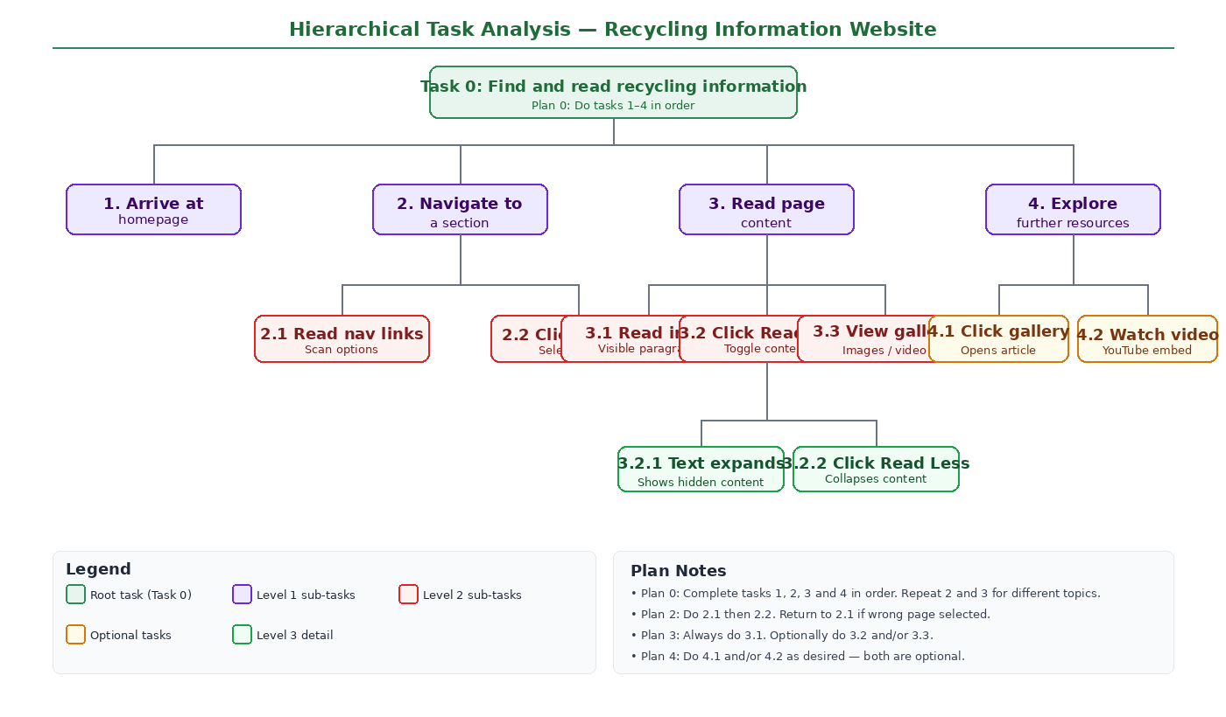
Figure 1: HTA Diagram — Find and read recycling information

3.3 HTA Plan Notes
- Plan 0: Finish tasks 1, 2, 3, and 4 sequentially. For other themes, repeat steps 2 and 3.
- Plan 2: Perform 2.1, then 2.2; if the incorrect page is chosen, go back to 2.1.
- Plan 3: Always perform 3.1; if necessary, perform 3.2 and/or 3.3.
- Plan 4: Complete optional enrichment steps 4.1 and/or 4.2.

- 3.4 The Interface's Visual Support
- Every page has the navigation bar, which helps to prevent confusion.
- To ensure viewers are in the correct section, each page has a distinct h1 heading.
- Although it is modest and lacks visual impact, the Read More button contains a text label.
- Before an image is clicked, the image gallery employs subtitles to provide context.
One notable gap is the absence of any active state or highlight on the current navigation link, which would help users track their position within the site.

Section 4: Environmental Analysis

4.1 Expected Usage Environments
- Home environment: Users using a laptop or desktop computer to browse in the evening or on the weekends.
- Students in an educational setting: a university library, a school computer lab, or when studying on their own.
- Community or voluntary setting: Margaret and other elderly users visiting the website at home or at a community centre.

4.2 Environmental Conditions and Their Impact on the UI
Environmental Factor | Potential Impact on the UI | Design Consideration
Indoor artificial lighting | Bright rooms can wash out low-contrast screens, making text on background images harder to read. | Ensure a minimum 4.5:1 contrast ratio (WCAG AA)
Variable device types | Mobile users experience navbar and gallery overflow. | Apply responsive CSS breakpoints.
Internet connection speed | Large image files up to 877 KB load slowly on weaker connections. | Compress and optimise images; consider lazy loading.
Ambient noise | YouTube embeds may startle users if autoplayed. | Remove autoplay from iframes.
Interruptions | Home users may pause and return, losing their place in long articles. | Progress indicators or anchor links would help.
Older hardware | Users like Margaret on older desktops may have slow page renders. | Reduce background image complexity.
Small screen size | 13-14 inch laptops may clip wide nav elements. | Test layout at 1024px width.

4.3 Accessibility Considerations
- Colour contrast: WebAIM Contrast Checker must be used to verify the background image and text.
- On a desktop, the 1.4rem body text font size is appropriate, but older users might prefer a larger default.
- Keyboard navigation: Only the Tab and Enter keys should be used to navigate this website.
- Alternative text: There is a serious accessibility issue with all gallery image alt attributes being empty (alt='').

Section 5: Usability Evaluation

5.1 Planning the Evaluation

Participants
Participant | Age | Background | Persona Proxy | Prior Experience
Participant 1 | 21 | Computing student | Persona 1 (Aoife — student researcher) | None
Participant 2 | 22 | Business student | Persona 2 (Declan — general interest user) | None

Evaluation Task
"You are interested in finding out why recycling matters and which countries are the worst at recycling," each participant was instructed. Use this page to locate that information and read as much as you require.

Metrics Collected
Metric | Definition | How Measured
Effectiveness | Did the user successfully complete the task? | Binary Yes/No observation
Efficiency | How long did the task take? | Stopwatch in seconds
Errors | Incorrect clicks or backtracking steps | Manual tally during observation
Satisfaction | How satisfied was the user? | Post-task rating 1-5
Learnability | How quickly did the user understand navigation? | Observer rating 1-5

Post-Task Questions
- Before clicking any of the navigation links, were you aware of what they would lead you to?
- Have you noticed the button to read more? Have you figured out what it would do?
- How did you feel about the pages' general design and readability?
- Was there anything you could not discover or that perplexed you?
- What is the one aspect of the website that you think needs improvement the most?

5.2 Results

Quantitative Results
Metric | Participant 1 | Participant 2 | Average
Effectiveness | Yes (completed) | Yes (completed) | 100% completion rate
Efficiency (seconds) | 94 seconds | 128 seconds | 111 seconds
Errors (incorrect clicks) | 2 | 4 | 3 errors
Satisfaction (1-5) | 3 | 3 | 3.0 / 5
Learnability (1-5) | 4 | 3 | 3.5 / 5

Key Usability Issues Identified
Issue | Observed Behaviour | Priority
Long navigation label | Both participants paused when scanning the nav bar, unsure what 'Countries failing to Recycle' contained. | High
Read More button unclear | Participant 2 scrolled past the button and missed it; neither user understood how much content was hidden. | High
Background reduces contrast. | Participant 2 commented that the text was hard to read on some pages due to the background image. | Medium
No active nav state | Neither participant could tell which page they were on from the nav bar alone. | Medium
Empty image alt text | Identified during post-review as an accessibility failure (not observed in testing) | Medium
Personal details in the footer | Participant 1 noticed the phone number and commented it seemed unusual for a public website. | Low
No search functionality | Participant 2 attempted Ctrl+F, suggesting they expected a search feature. | Low

Participant Quotes (Think-Aloud Protocol)
Participant One: "I clicked Importance first because that seemed obvious — but I was not sure if Countries failing to Recycle was different from that or just more detail."
Participant 2: "Oh, I absolutely missed that button. I believed that was all the information on the page.
Respondent 2: "The background makes it a little tricky — like the image behind the text kind of blends in."

Section 6: UI Redesign

6.1 Overview
Based on the usability evaluation's findings, six specific redesign improvements are recommended. Each change directly addresses a specific usability issue and is linked to the most advantageous personality.

6.2 Change 1 — Navigation Bar
Aspect | Detail
Issue Addressed | Long, ambiguous navigation link 'Countries failing to Recycle'
Proposed Change | Rename to 'Global Recycling Rates'. Add an active page highlight in lighter green. Increase spacing between links.
Personas Benefited | All personas — particularly Declan and Margaret, who are less likely to read long labels carefully
Expected UX Gain | Reduced cognitive load; faster task completion; fewer incorrect page selections

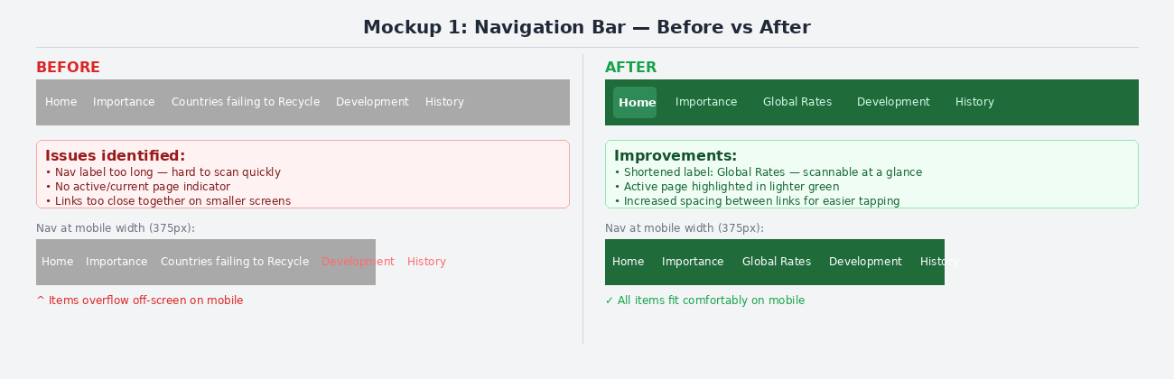
Figure 2: Mockup 1 — Navigation Bar Before (left) vs After (right)

6.3 Change 2 — Read More Button
Aspect | Detail
Issue Addressed | The 'Read More' button is small, plain, and easily overlooked.
Proposed Change | Style with a green background, white text, rounded corners and an arrow icon. Add hint text below collapsed content: 'Tap to read more about this topic'.
Personas Benefited | Declan (reads quickly, may miss small elements); Margaret (may not recognise the button as interactive)
Expected UX Gain | More users engage with full content; the satisfaction score is expected to improve from 3.0 to 4.0+.

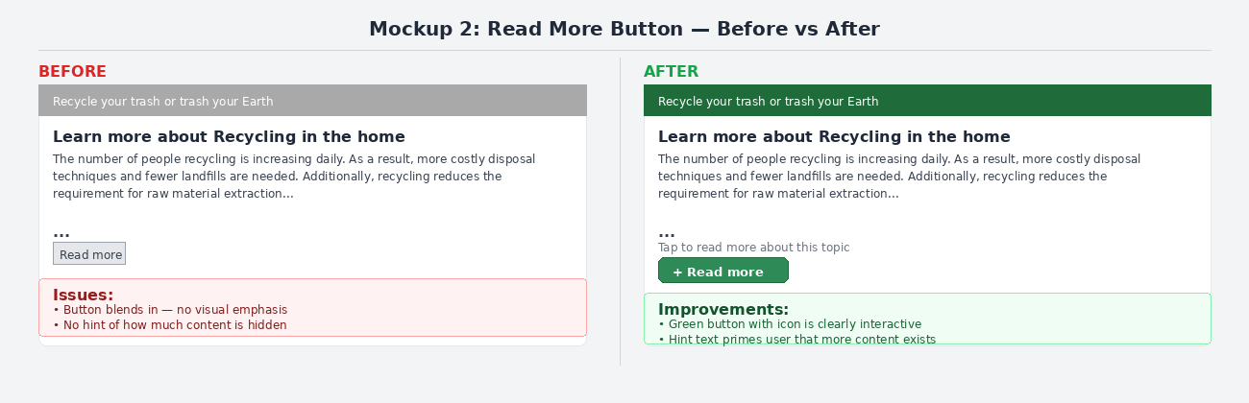
Figure 3: Mockup 2 — Read More Button Before (left) vs After (right)

6.4 Change 3 — Background and Contrast
Aspect | Detail
Issue Addressed | The background image reduces text contrast and legibility across all pages.
Proposed Change | Remove full-page background image. Use a clean white page background. Retain the image as a decorative header banner on the homepage only, with a dark overlay behind the header text.
Personas Benefited | Margaret (struggles with low contrast); all users benefit from improved readability.
Expected UX Gain | WCAG AA compliance (4.5:1 contrast ratio); reduced eye strain; faster page load

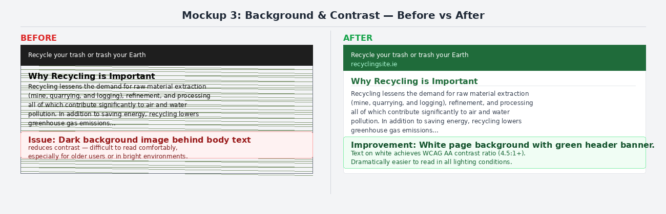
Figure 4: Mockup 3 — Background & Contrast Before (left) vs After (right)

6.5 Change 4 — Active Navigation State
Aspect | Detail
Issue Addressed | Users cannot identify which page they are currently viewing from the nav bar.
Proposed Change | Apply a CSS active class to the current page's nav link — distinct green background and underline. Can be implemented via JavaScript checking the current URL.
Personas Benefited | All personas — particularly Aoife, who navigates quickly between sections
Expected UX Gain | Reduced navigation errors; improved orientation; learnability score expected to improve from 3.5 to 4.5

6.6 Change 5 — Image Alt Text
Aspect | Detail
Issue Addressed | All gallery images have empty alt attributes (alt=''), invisible to screen readers.
Proposed Change | Add meaningful descriptive alt text to every image. Example: alt='Industrial pollution rising from a factory chimney, illustrating the environmental impact of not recycling'
Personas Benefited | Any user relying on a screen reader also benefits from search engine indexing.
Expected UX Gain | WCAG 2.1 Level A compliance; improved accessibility for visually impaired users

6.7 Change 6 — Remove Personal Phone Number
Aspect | Detail
Issue Addressed | Personal phone number displayed publicly on every page footer
Proposed Change | Remove the phone number from the footer. Retain the name and student email as contact details. Replace with a contact form page if further contact options are needed.
Personas Benefited | Improves professional credibility and user trust across all personas
Expected UX Gain | Improved perceived professionalism and trustworthiness of the website

6.8 Summary of Expected UX Gains
Change | Metric Targeted | Expected Improvement
Shorter nav label + active state | Efficiency / Errors / Learnability | Faster task time, fewer wrong clicks, better orientation
Redesigned Read More button | Satisfaction / Effectiveness | More content engaged with; higher satisfaction rating
Solid background / better contrast | Accessibility / Satisfaction | WCAG AA compliance; reduced reading difficulty
Active nav state | Learnability / Errors | Users always know where they are.
Descriptive alt text | Accessibility | Screen reader compatibility achieved
Remove phone number. | Trust / Professionalism | Improved site credibility

References

- Nielsen, J. (1994). Usability Engineering. Morgan Kaufmann. Referenced for usability metrics: effectiveness, efficiency, satisfaction.
- W3Schools (2024). How To — Read More. https://www.w3schools.com/howto/howto_js_read_more.asp — Source of Read More JavaScript used in original project.
- WebAIM (2024). Contrast Checker. https://webaim.org/resources/contrastchecker/ — Used to assess colour contrast ratios.
- W3C (2023). Web Content Accessibility Guidelines (WCAG) 2.1. https://www.w3.org/TR/WCAG21/ — Referenced for accessibility compliance criteria.
- Xtensio (2024). User Persona Template. https://xtensio.com/user-persona-template/ — Referenced for structuring persona format.
- Materialsrecovery.co.uk (2024). How does recycling reduce pollution? https://www.materialsrecovery.co.uk/blog/how-does-recycling-reduce-pollution — Linked in homepage gallery.
- Google Fonts (2024). Afacad Flux. https://fonts.google.com/specimen/ Afacad+Flux — Font used throughout the website.

